PRACTICE PROBLEMS BASED ON ROUND ROBIN SCHEDULING-

Problem-01:

Consider the set of 5 processes whose arrival time and burst time are given below-

Process Id | Arrival time | Burst time
P1 | 0 | 5
P2 | 1 | 3
P3 | 2 | 1
P4 | 3 | 2
P5 | 4 | 3

If the CPU scheduling policy is Round Robin with time quantum = 2 unit, calculate the average waiting time and average turn around time.
Advertisements

Solution-

Gantt Chart-

Ready Queue-
P5, P1, P2, P5, P4, P1, P3, P2, P1

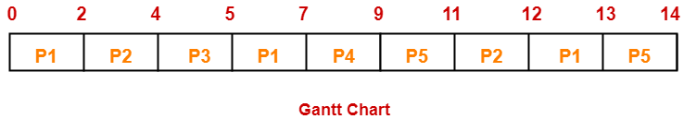

Now, we know-
- Turn Around time = Exit time – Arrival time
- Waiting time = Turn Around time – Burst time

Process Id | Exit time | Turn Around time | Waiting time
P1 | 13 | 13 – 0 = 13 | 13 – 5 = 8
P2 | 12 | 12 – 1 = 11 | 11 – 3 = 8
P3 | 5 | 5 – 2 = 3 | 3 – 1 = 2
P4 | 9 | 9 – 3 = 6 | 6 – 2 = 4
P5 | 14 | 14 – 4 = 10 | 10 – 3 = 7

Now,
- Average Turn Around time = (13 + 11 + 3 + 6 + 10) / 5 = 43 / 5 = 8.6 unit
- Average waiting time = (8 + 8 + 2 + 4 + 7) / 5 = 29 / 5 = 5.8 unit

Problem-02:

Consider the set of 6 processes whose arrival time and burst time are given below-

Process Id | Arrival time | Burst time
P1 | 0 | 4
P2 | 1 | 5
P3 | 2 | 2
P4 | 3 | 1
P5 | 4 | 6
P6 | 6 | 3

If the CPU scheduling policy is Round Robin with time quantum = 2, calculate the average waiting time and average turn around time.

Solution-

Gantt chart-

Ready Queue-
P5, P6, P2, P5, P6, P2, P5, P4, P1, P3, P2, P1

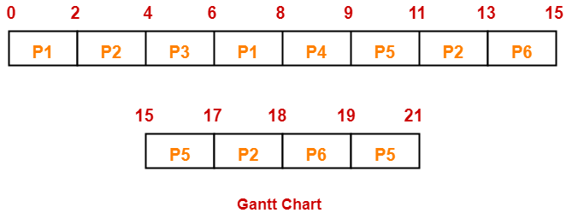

Now, we know-
- Turn Around time = Exit time – Arrival time
- Waiting time = Turn Around time – Burst time

Process Id | Exit time | Turn Around time | Waiting time
P1 | 8 | 8 – 0 = 8 | 8 – 4 = 4
P2 | 18 | 18 – 1 = 17 | 17 – 5 = 12
P3 | 6 | 6 – 2 = 4 | 4 – 2 = 2
P4 | 9 | 9 – 3 = 6 | 6 – 1 = 5
P5 | 21 | 21 – 4 = 17 | 17 – 6 = 11
P6 | 19 | 19 – 6 = 13 | 13 – 3 = 10

Now,
- Average Turn Around time = (8 + 17 + 4 + 6 + 17 + 13) / 6 = 65 / 6 = 10.84 unit
- Average waiting time = (4 + 12 + 2 + 5 + 11 + 10) / 6 = 44 / 6 = 7.33 unit
Problem-03:

Consider the set of 6 processes whose arrival time and burst time are given below-

Process Id | Arrival time | Burst time
P1 | h5 | 5
P2 | 4 | 6
P3 | 3 | 7
P4 | 1 | 9
P5 | 2 | 2
P6 | 6 | 3

If the CPU scheduling policy is Round Robin with time quantum = 3, calculate the average waiting time and average turn around time.

Solution-

Gantt chart-

Ready Queue-
P3, P1, P4, P2, P3, P6, P1, P4, P2, P3, P5, P4
Advertisements
Discover more
CPU
Operating System
Operating system

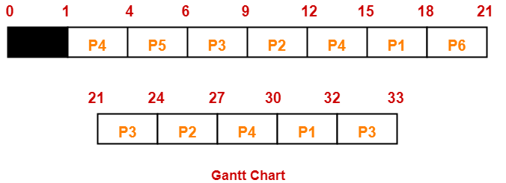

Now, we know-
- Turn Around time = Exit time – Arrival time
- Waiting time = Turn Around time – Burst time

Process Id | Exit time | Turn Around time | Waiting time
P1 | 32 | 32 – 5 = 27 | 27 – 5 = 22
P2 | 27 | 27 – 4 = 23 | 23 – 6 = 17
P3 | 33 | 33 – 3 = 30 | 30 – 7 = 23
P4 | 30 | 30 – 1 = 29 | 29 – 9 = 20
P5 | 6 | 6 – 2 = 4 | 4 – 2 = 2
P6 | 21 | 21 – 6 = 15 | 15 – 3 = 12

Now,
- Average Turn Around time = (27 + 23 + 30 + 29 + 4 + 15) / 6 = 128 / 6 = 21.33 unit
- Average waiting time = (22 + 17 + 23 + 20 + 2 + 12) / 6 = 96 / 6 = 16 unit

Problem-04:

Four jobs to be executed on a single processor system arrive at time 0 in the order A, B, C, D. Their burst CPU time requirements are 4, 1, 8, 1 time units respectively. The completion time of A under round robin scheduling with time slice of one time unit is-
- 10
- 4
- 8
- 9

Solution-

Process Id | Arrival time | Burst time
A | 0 | 4
B | 0 | 1
C | 0 | 8
D | 0 | 1

Gantt chart-

Ready Queue-
C, A, C, A, C, A, D, C, B, A

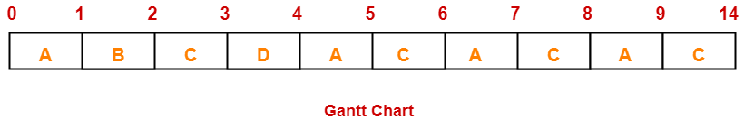

Clearly, completion time of process A = 9 unit.
Thus, Option (D) is correct.

